**This submission is original work and no part is plagiarized** (signed) _______________(Date)___________



**TIET, Patiala**

**MECHANICAL ENGINEERING DEPARTMENT**

**Assignment - 1.**

**Dynamics for the Mangonel-No Drag**

***UTA013 Engineering Design Project-I***

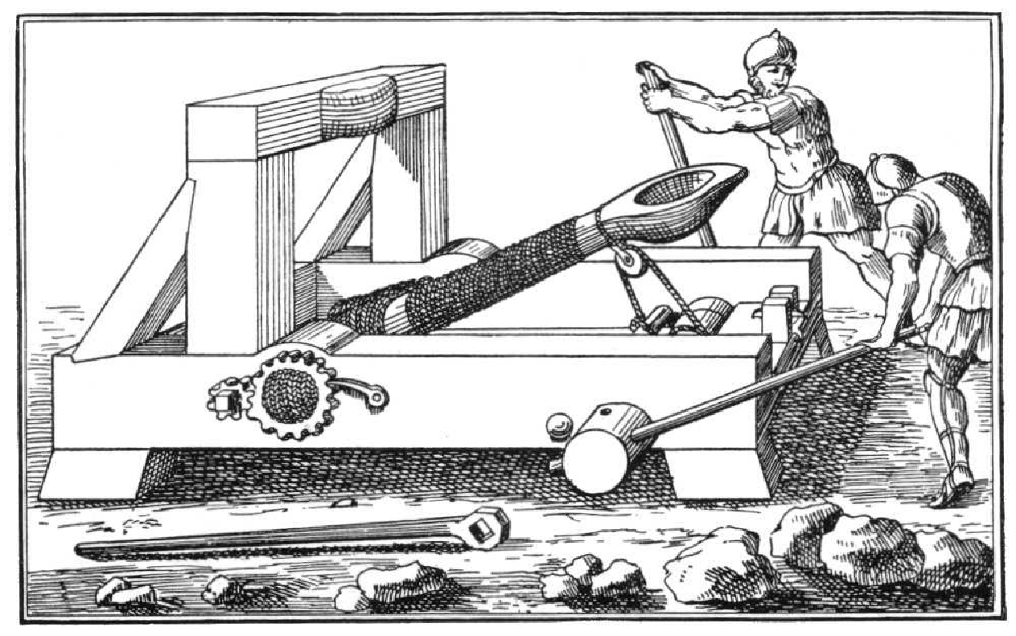

**Assignment - 1.**

**Dynamics for the Mangonel-No Drag**

The following assignment has been based on the lecture on projectile dynamics for the Mangonel -with **No drag**. Complete the following **individually, copying will be dealt with severely**.

**Notes:**

1. Ensure on all graphs the curve is visible and sufficient resolution is provided so that the height and distance is determinable. The following chart is an example for 70 degrees at 22m/s.

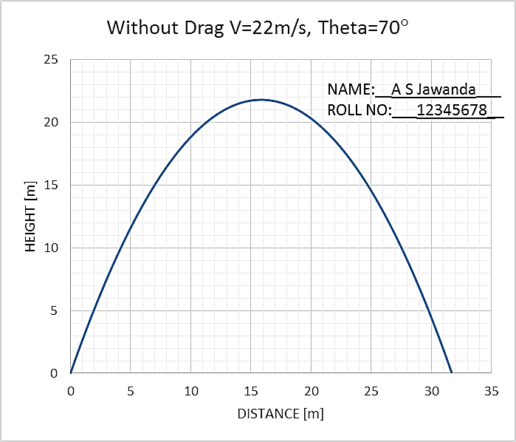

1. **The excel graph and results for : One Launch angle in degrees, velocity in m/s have to be shown for evaluation on the same day.** While the print of this word document with **graphs (with Name and Roll No in text box)** and **hand written conclusion, name and roll number on every page**, stapled together, is to be submitted in next Tutorial class (if it is a holiday, then as instructed).
2. Do not leave this assignment until the last minute to find you have some IT issue.

Enjoy the assignment and try to think around the subject as much as possible and take from it any tips that you might use with your own Mangonel design.

**Marking Scheme:**

**Tutorial 1 Total = 10 Marks**

**Evaluation at end of 2 Hours Tutorial 1= 5**

**Submission of Tutorial 1 print tagged in folder=5**

**Weightage Assignment 1 (10 Marks) + Assignment 2 (10 Marks) = 10% for both.**

**TUTORIAL CLASS EVALUATION [5 Marks]**

**Only Q1e below evaluated at the end of 2 Hours of tutorial class on computer.**

**One Marks each for:**

1. **Excel sheet formulation,**
2. **Layout,**
3. **Graph series,**
4. **Graph clarity and**
5. **Graph format, as given in note.**
6. Using the Excel spread sheet that you have developed to model the dynamics of a “missile” cast by the Mangonel, copy and paste graphs for the following into this document
   1. No drag: Launch angle 20 degrees, velocity 10m/s

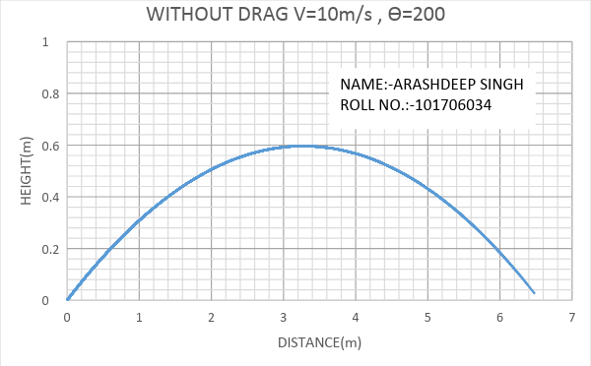

* 1. No drag: Launch angle 30 degrees, velocity 10m/s

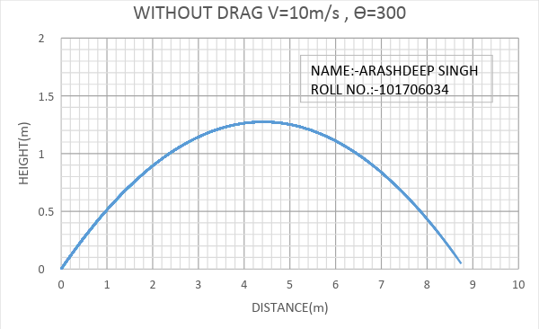

* 1. No drag: Launch angle 45 degrees, velocity 10m/s

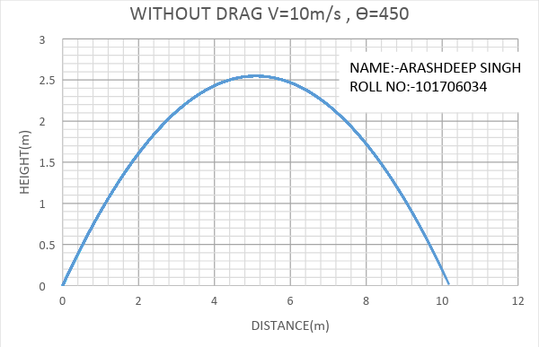

* 1. No drag: Launch angle 60 degrees, velocity 10m/s

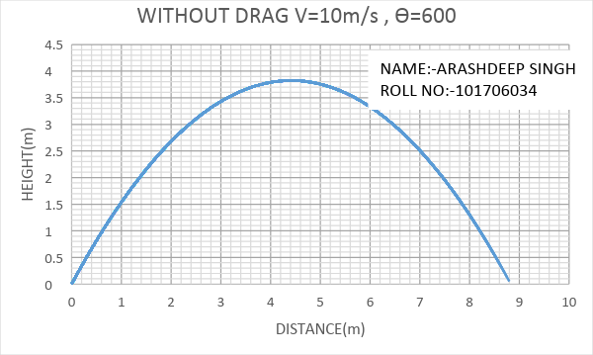

* 1. No drag: Launch angle 70 degrees, velocity 10m/s

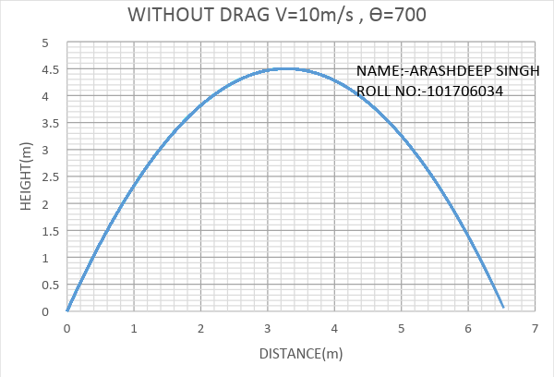

1. Plot a combined graph for No drag: Launch velocity 20m/s for angle varying from 20 degrees to 80 degrees in step of 5 degrees.

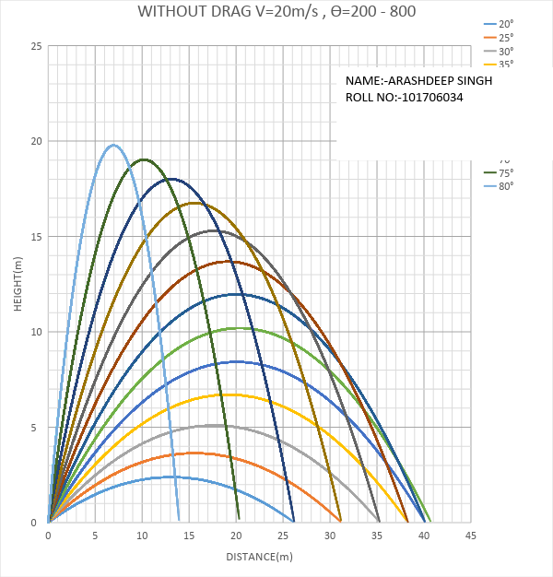

1. Plot a combined graph for No drag: Angle 45 degrees and launch velocity varying from 5m/s to 45 m/s in step of 5 m/s.

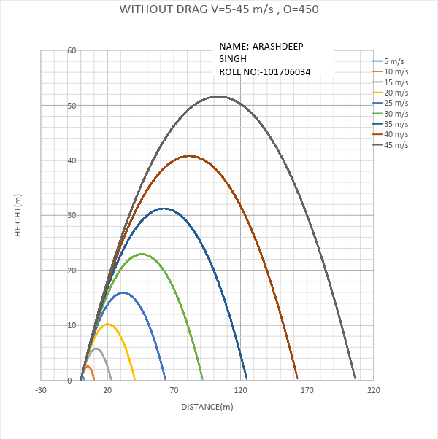

1. For the combined graphs in Q1, Q2 and Q3 comment on the effect of angle of launch and velocity on the horizontal distance travelled.

|  |
| --- |
|  |
|  |
|  |
|  |
|  |
|  |
|  |
|  |
|  |
|  |
|  |
|  |
|  |
|  |
|  |
|  |
|  |

**END**